MEDICAL STORE

*by* A Harsha Vardhan Royal

**Submission date:** 23-Dec-2020 12:22PM (UTC+0530)

**Submission ID:** 1480791026

**File name:** 1NH18CS001.pdf (540.74K)

**Word count:** 4211

**Character count:** 20964

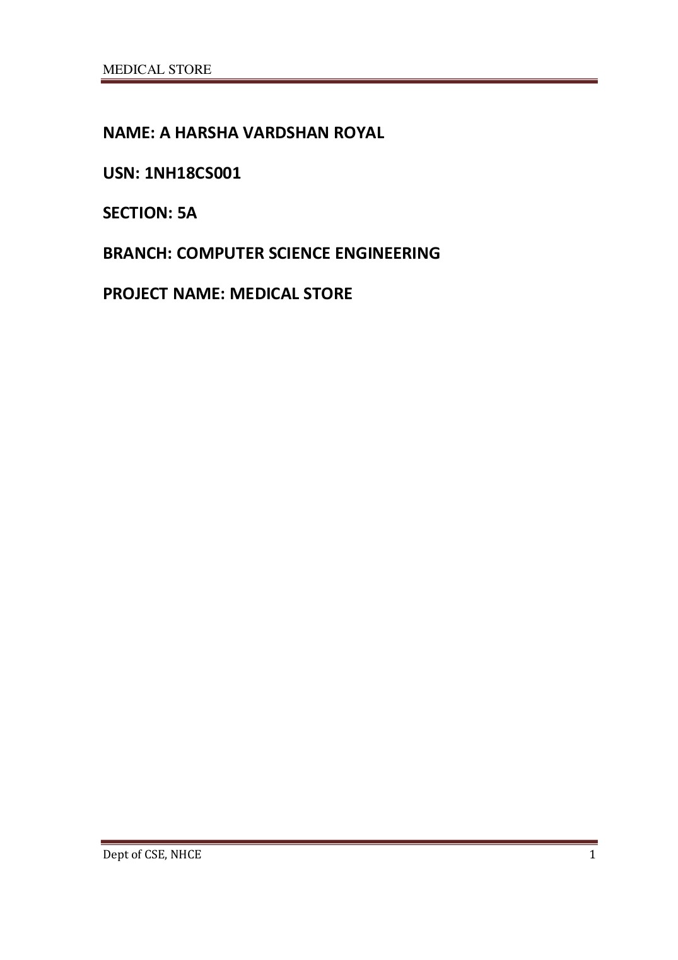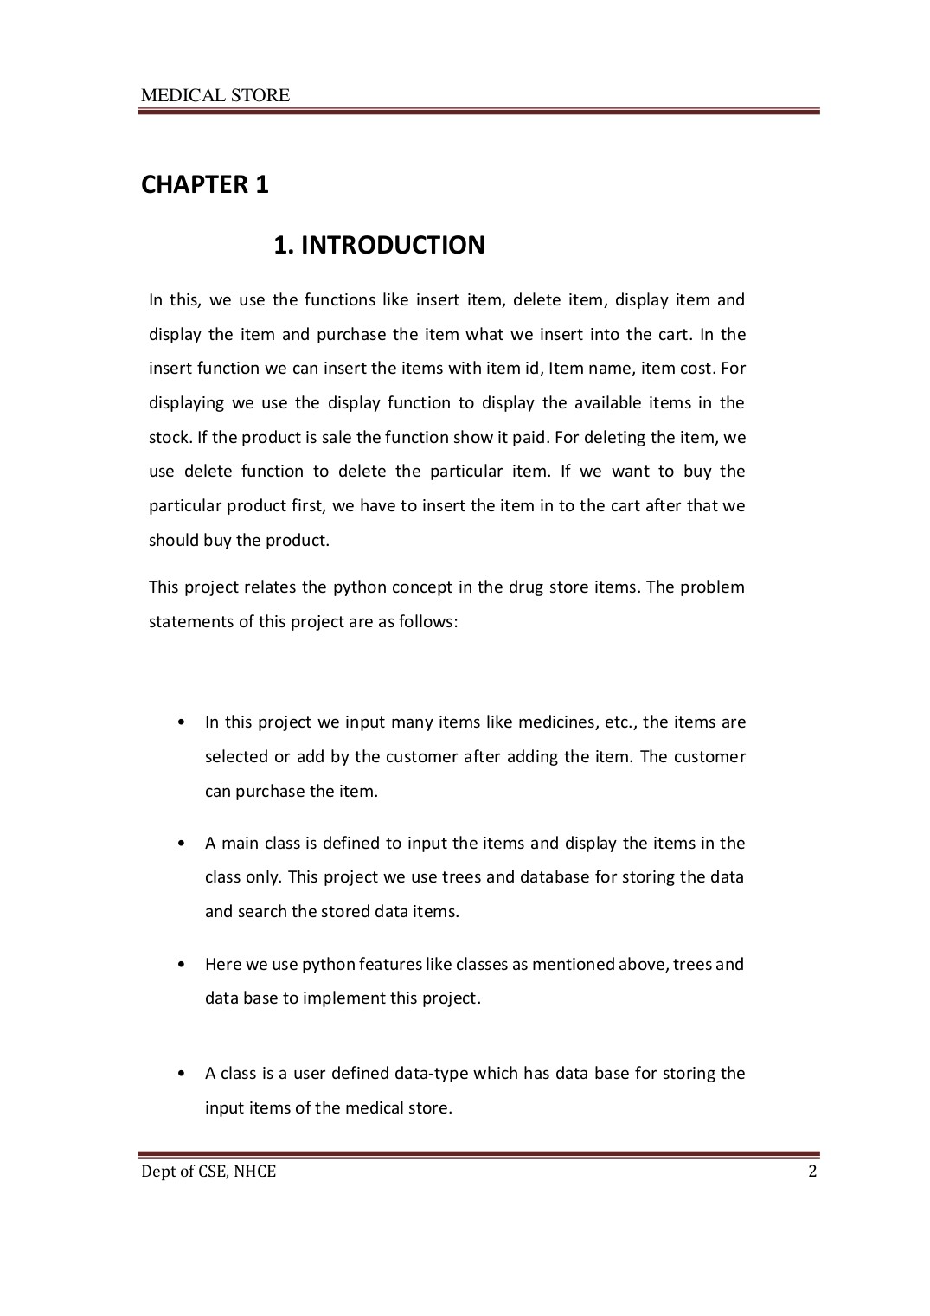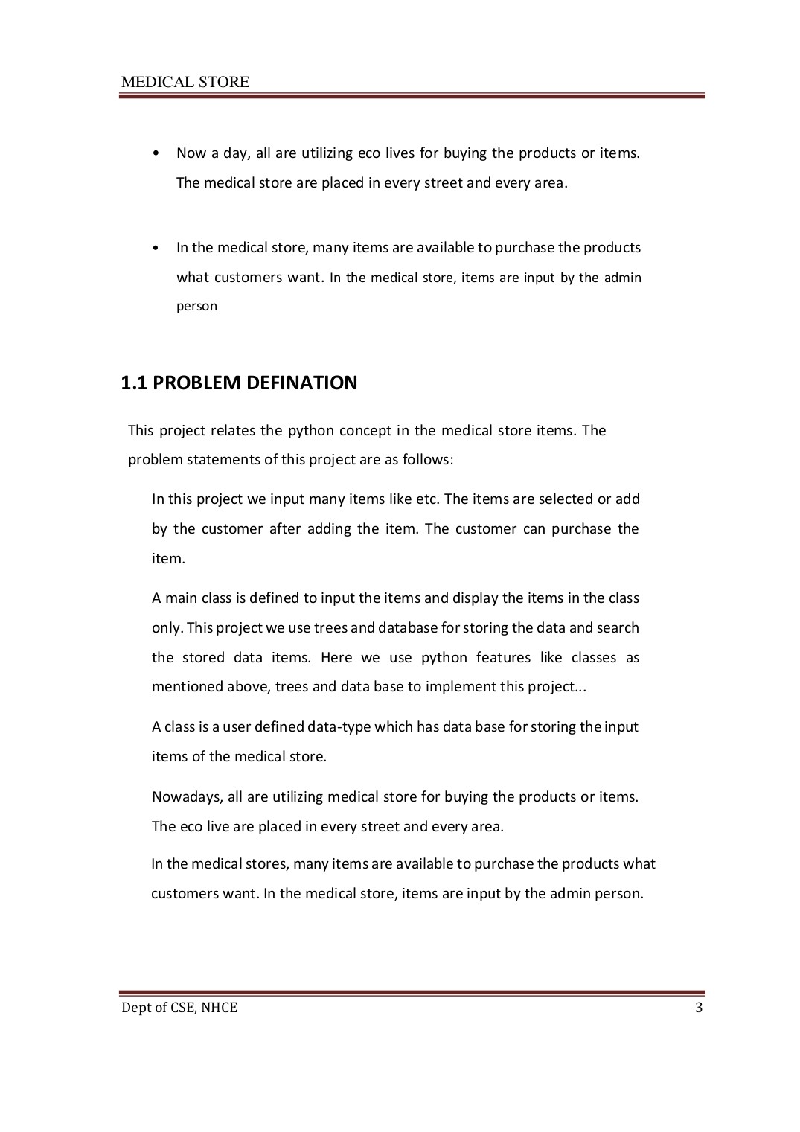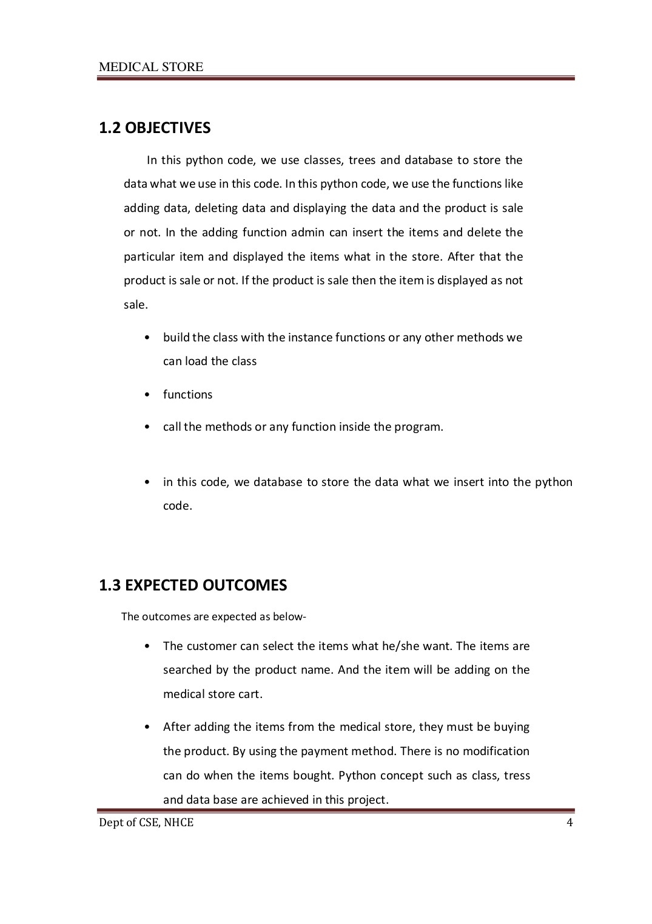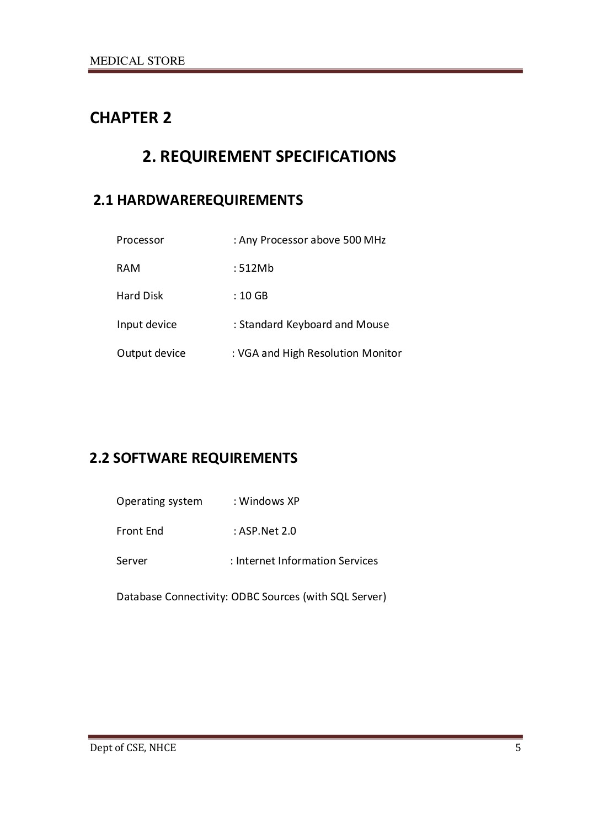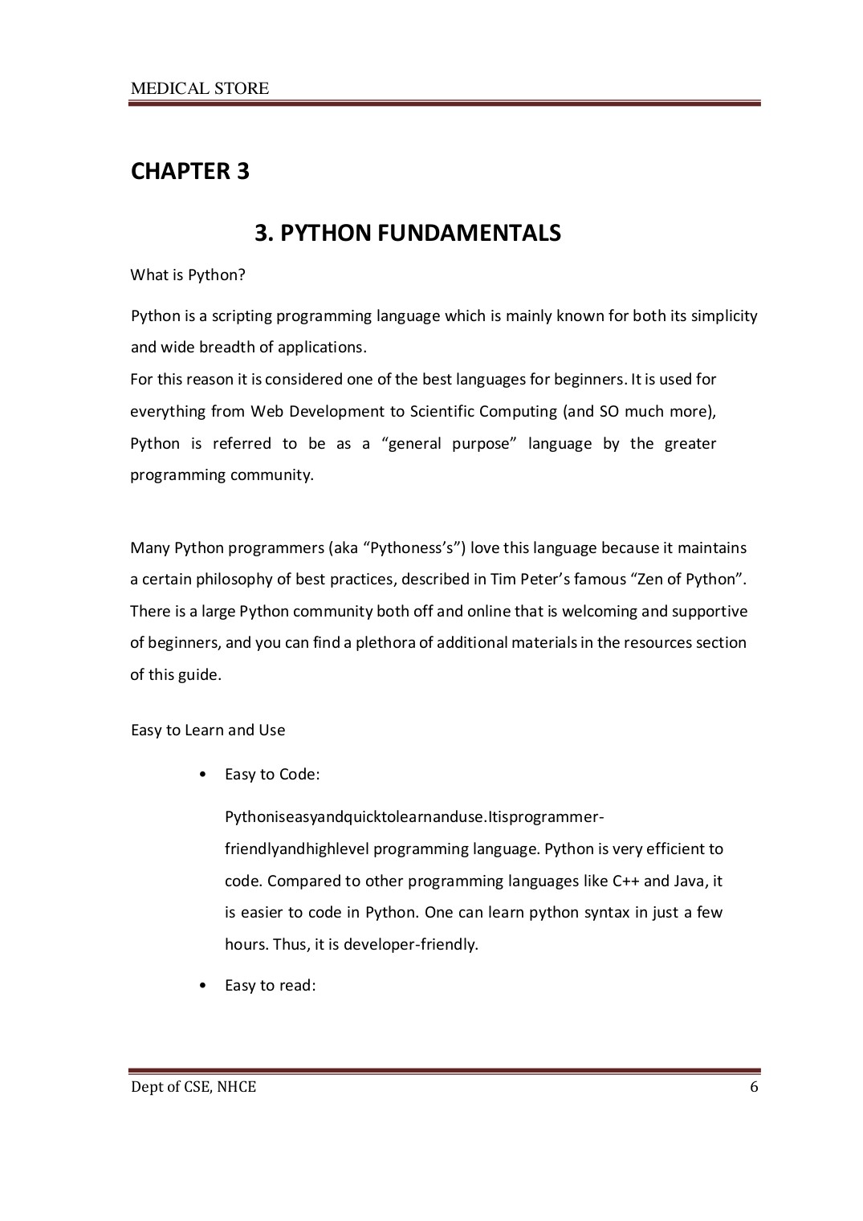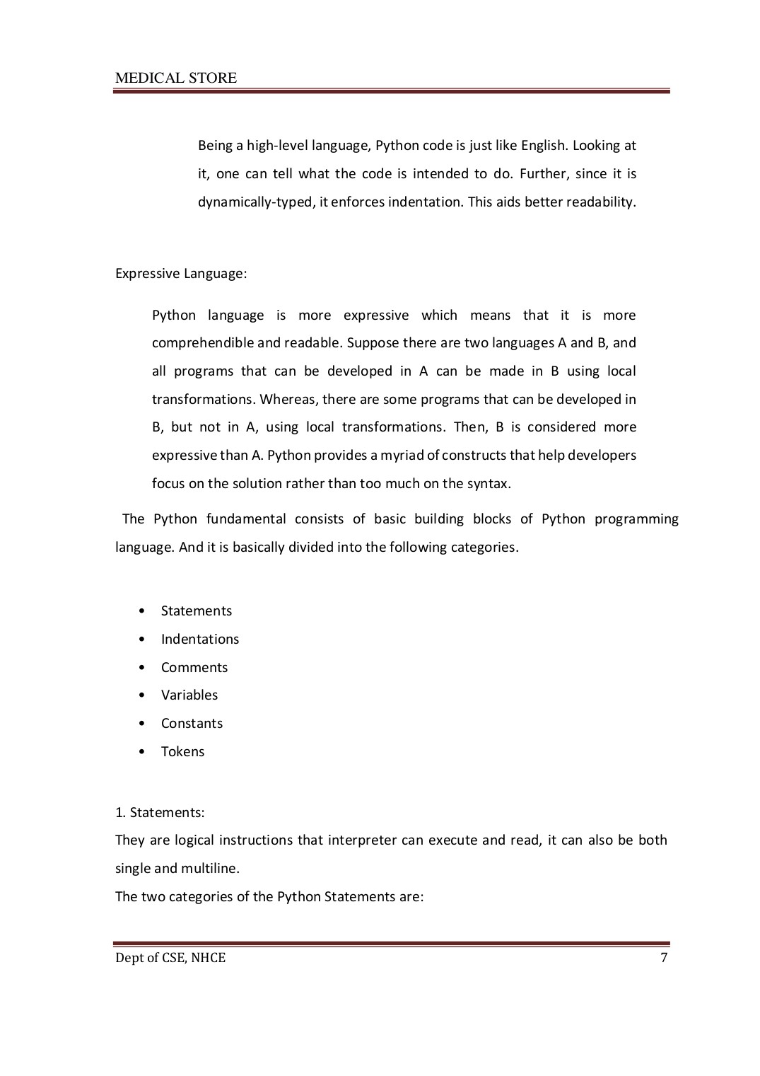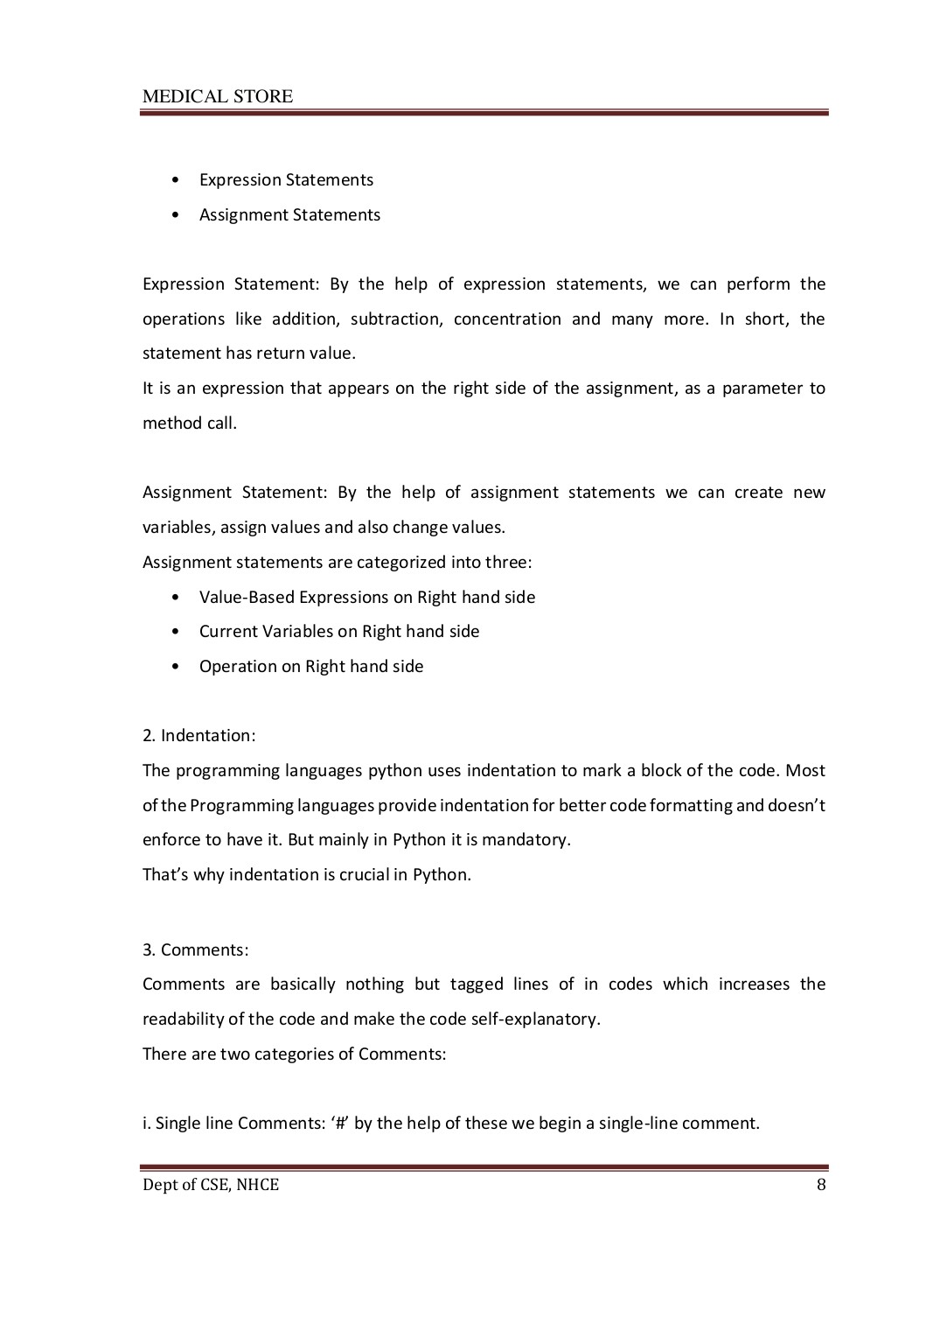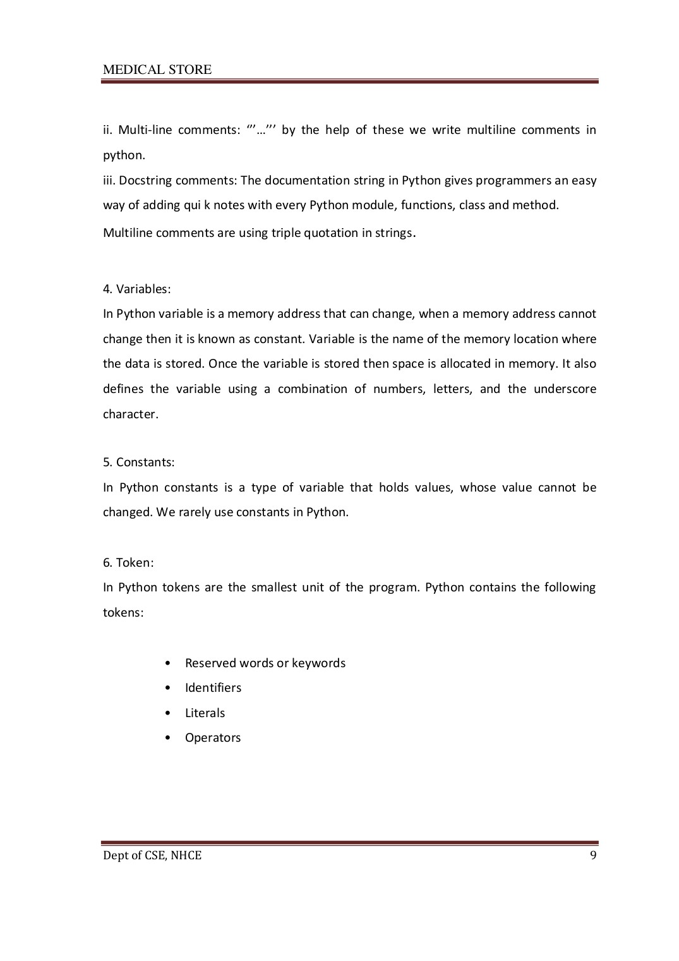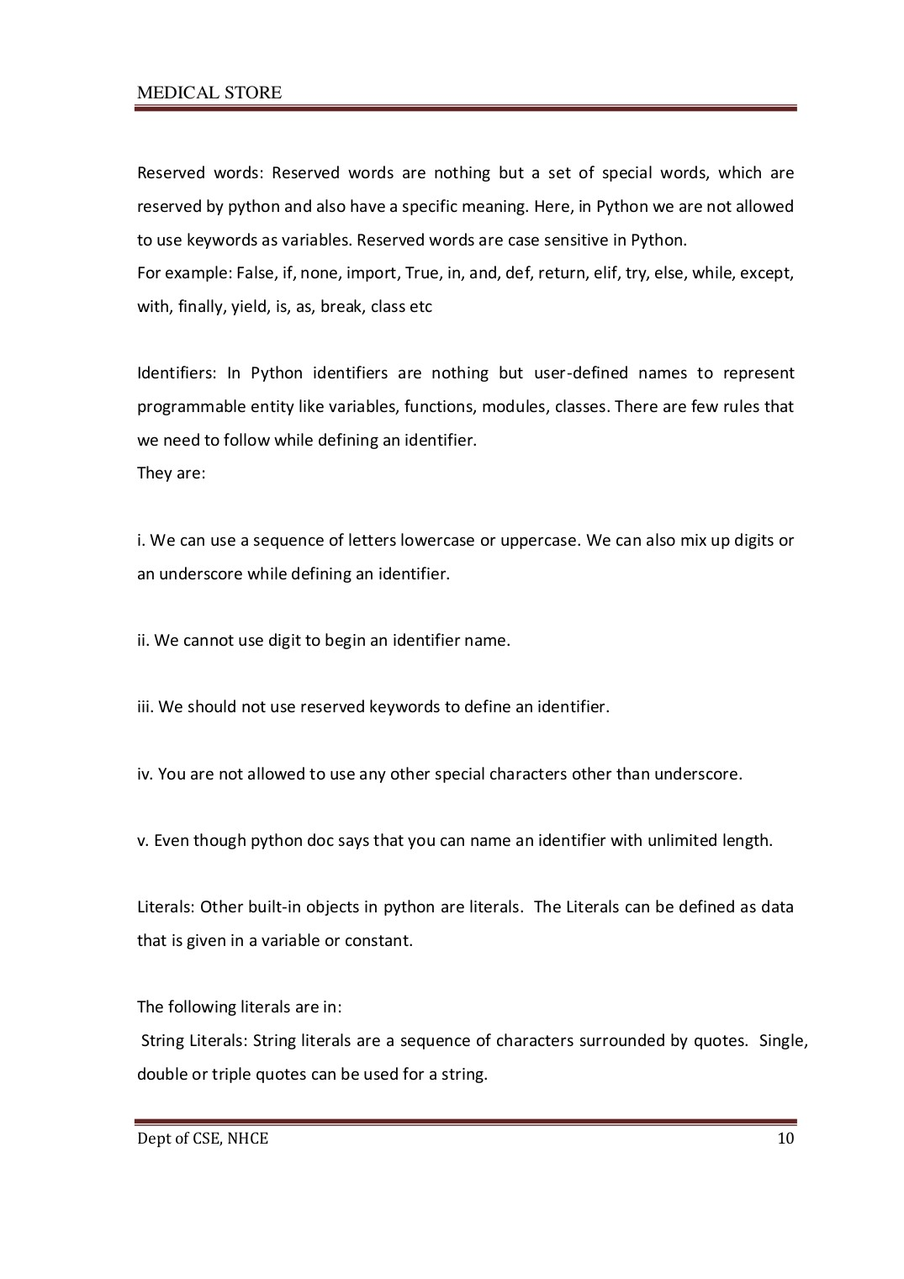

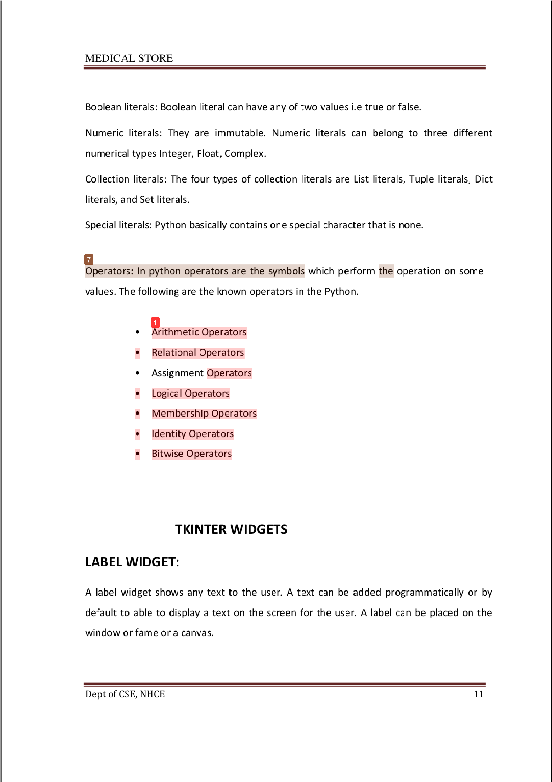

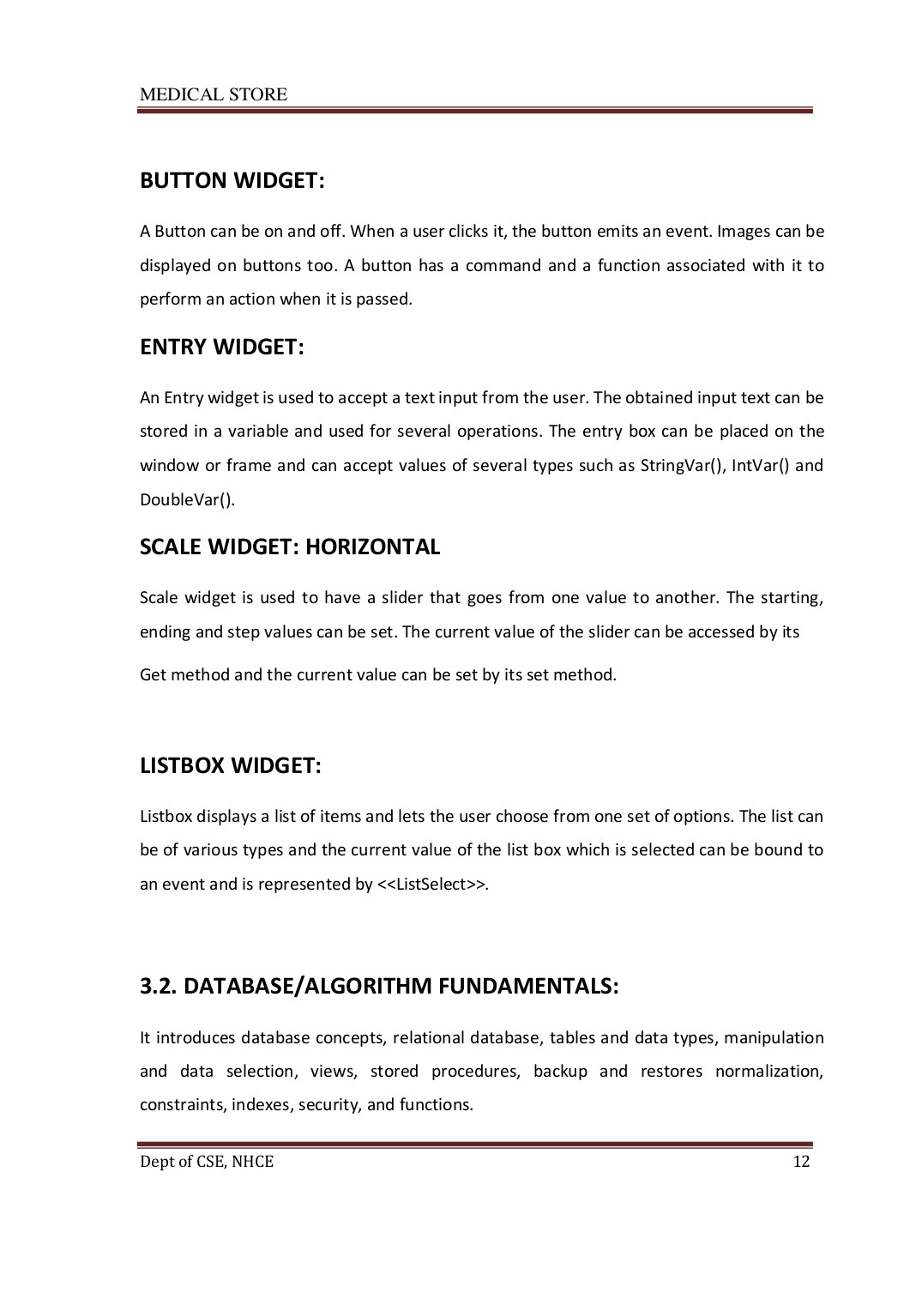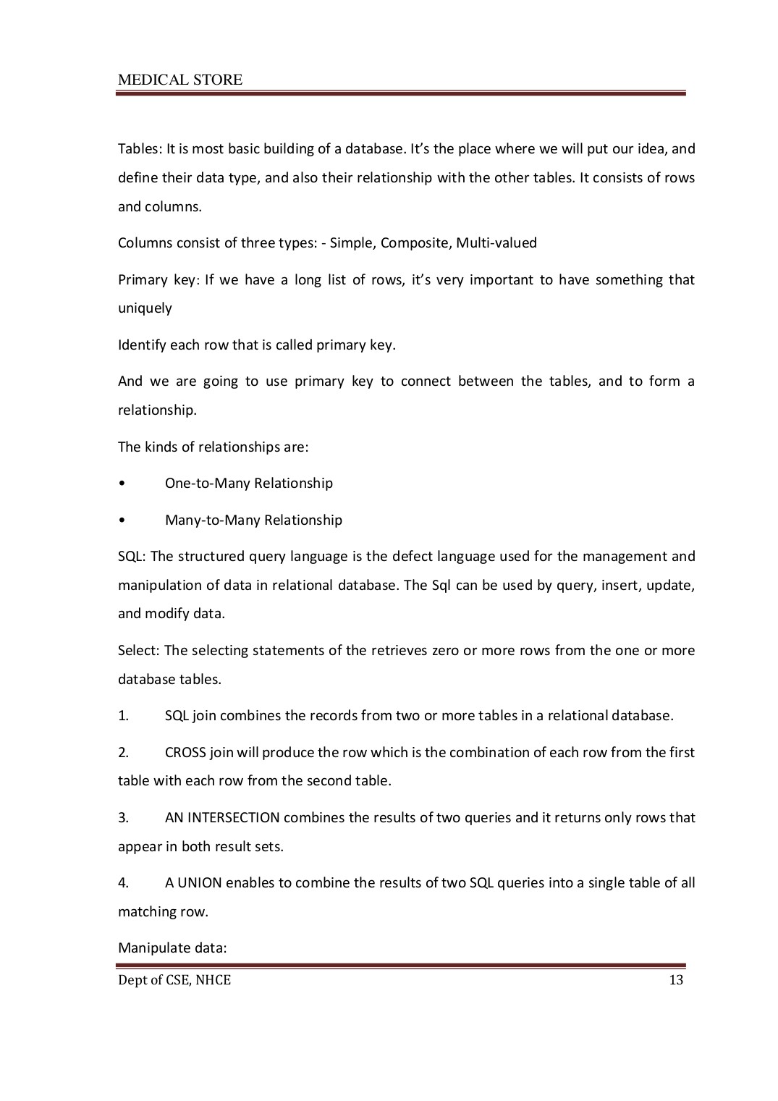

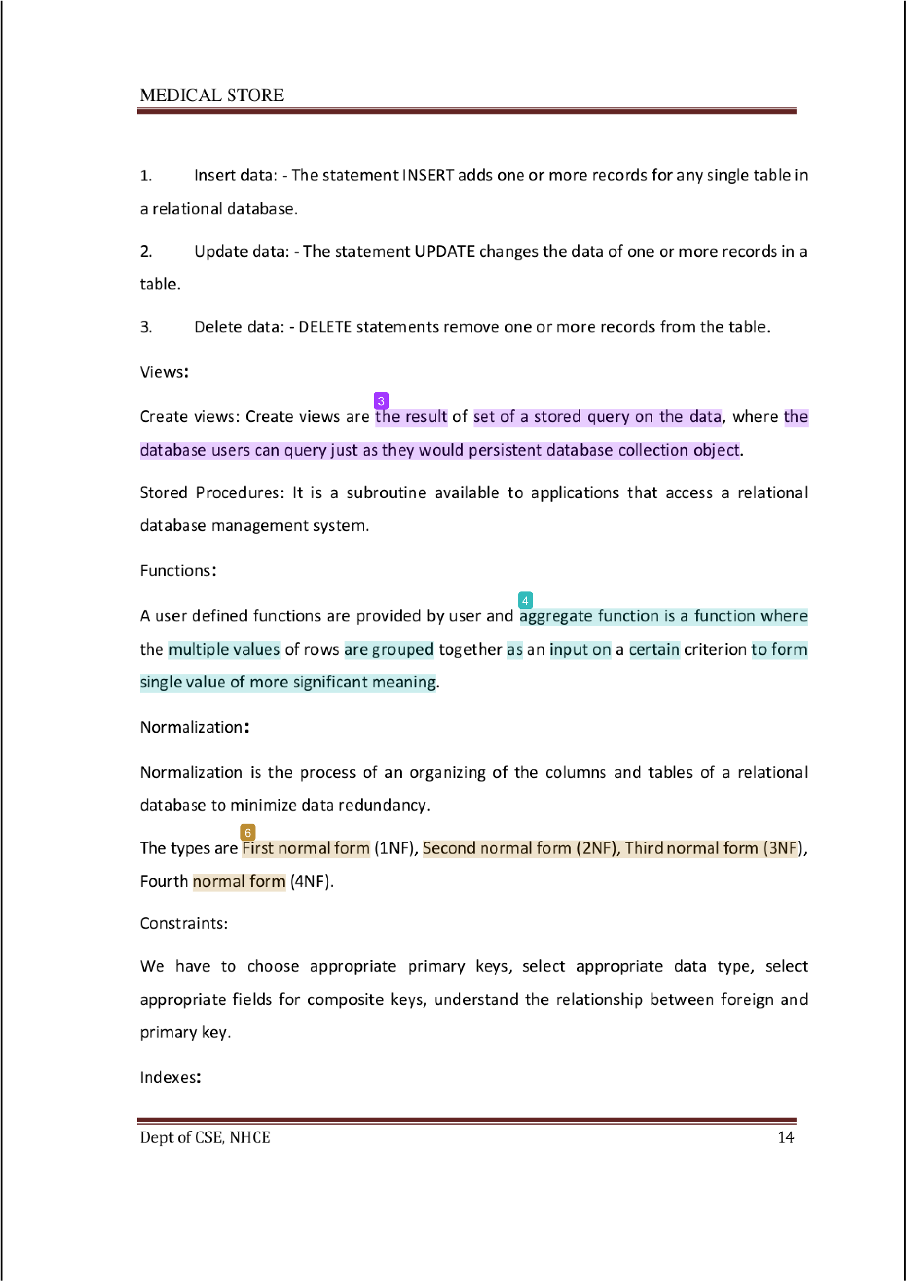

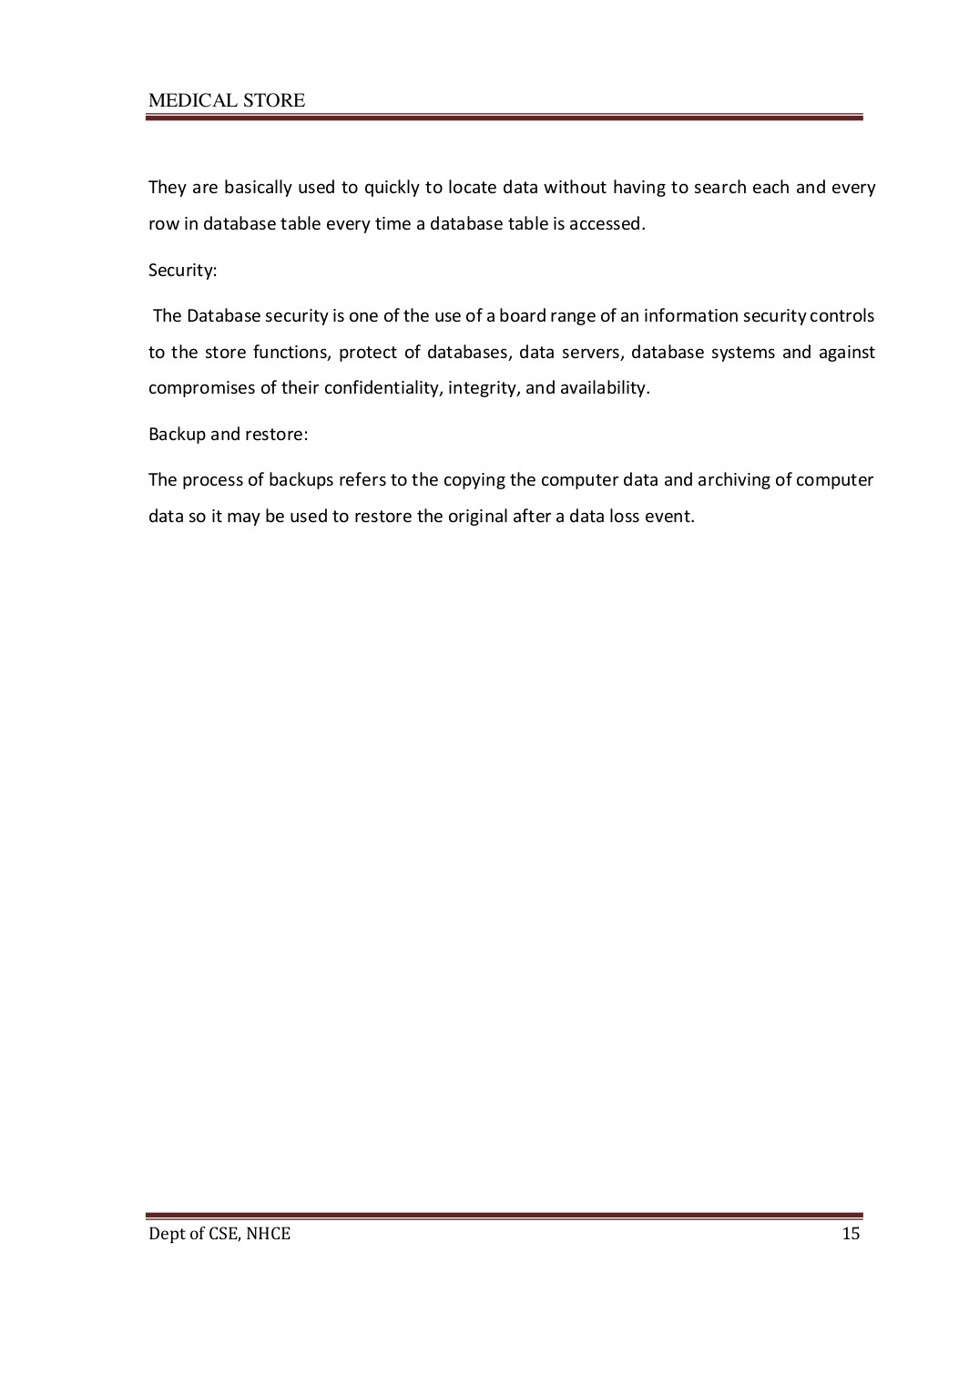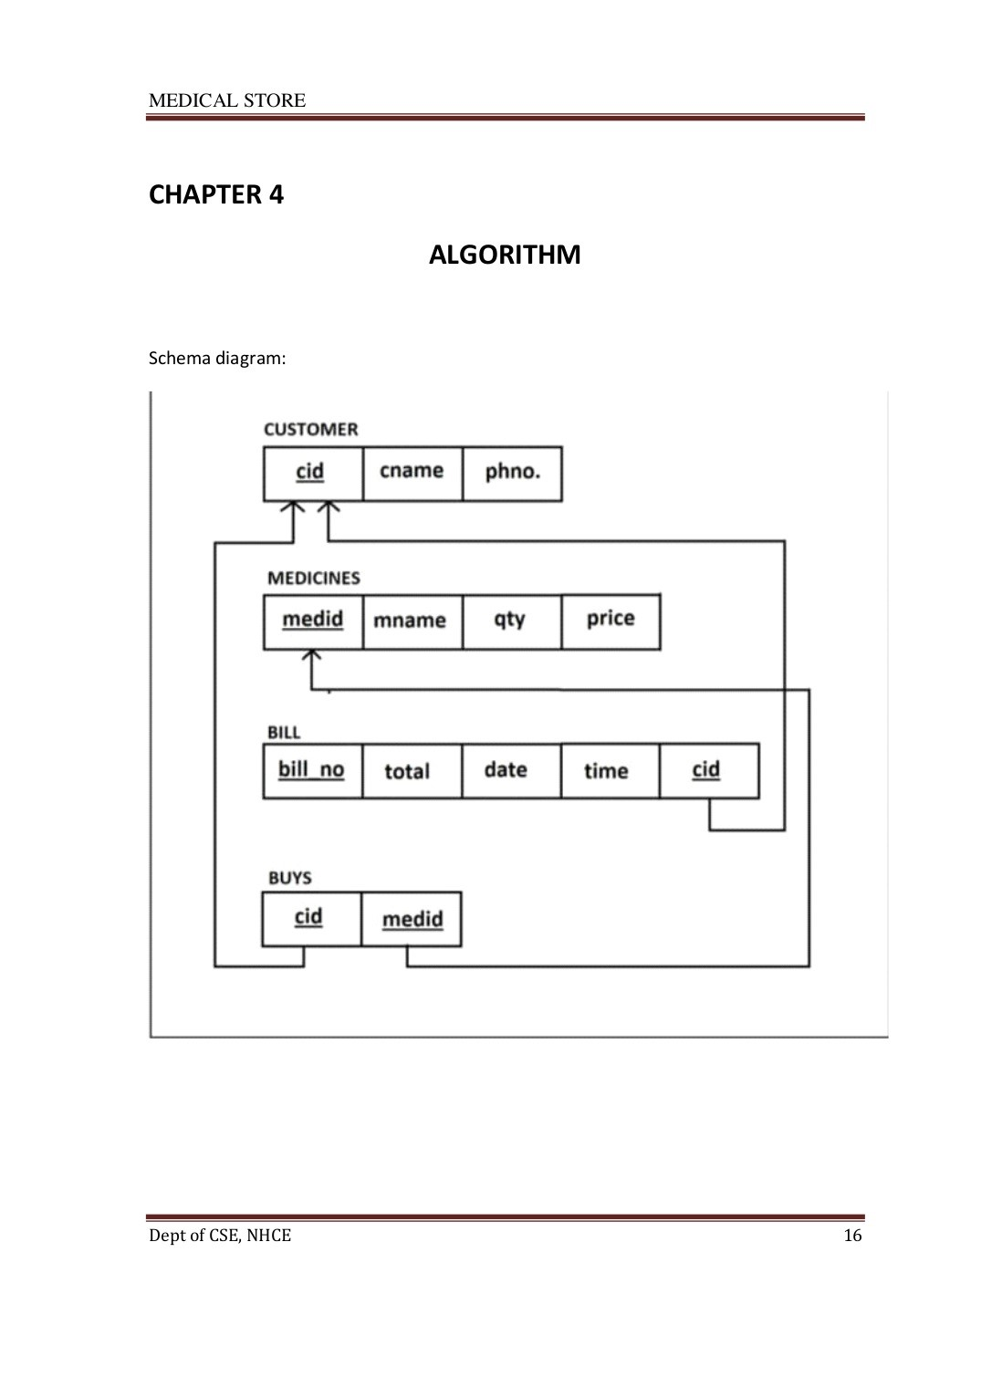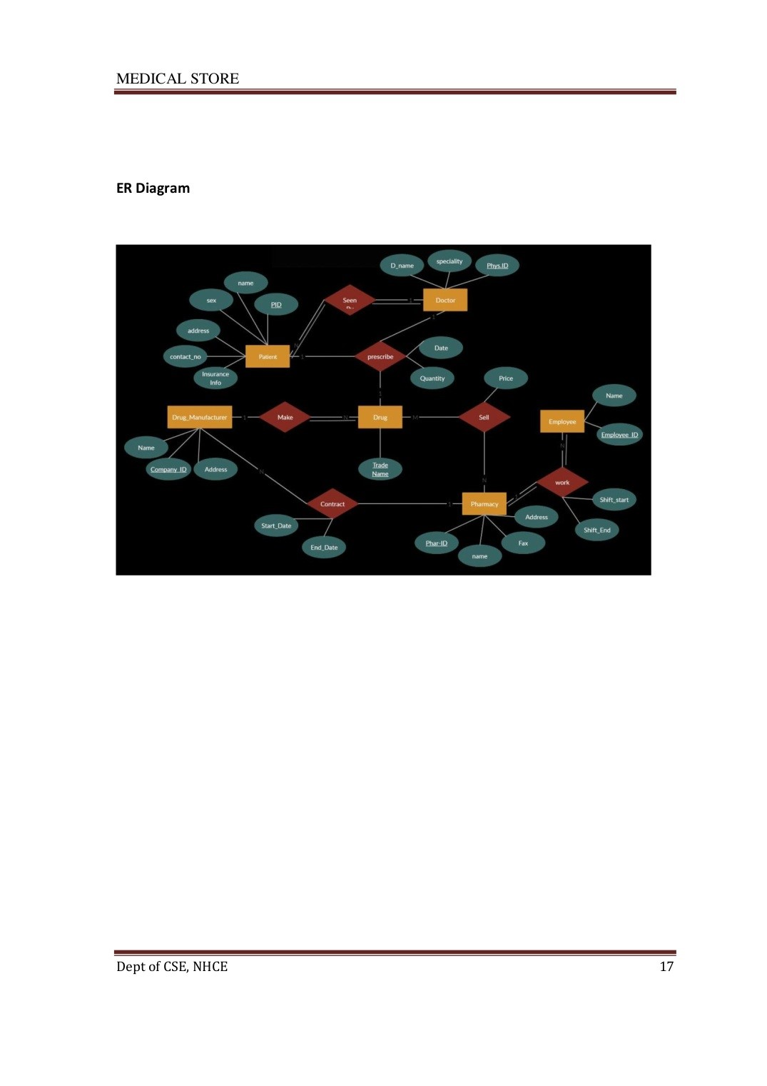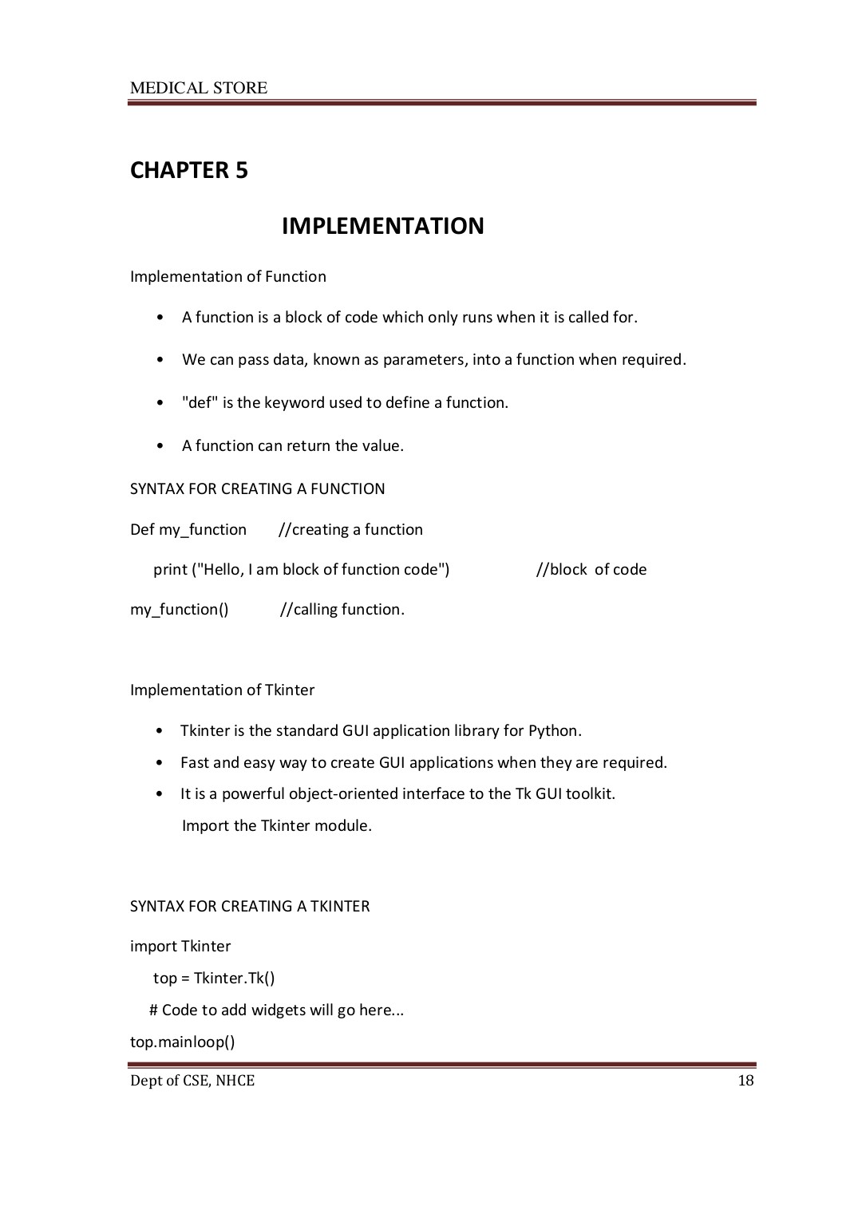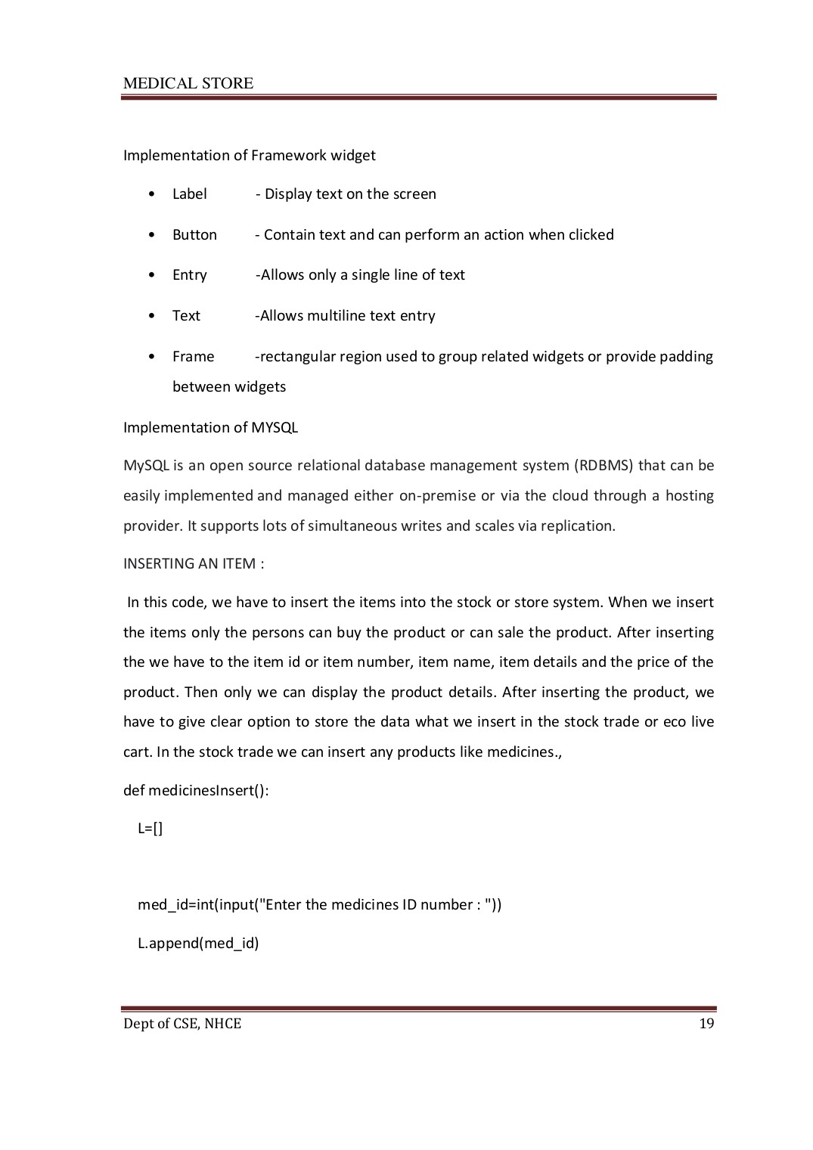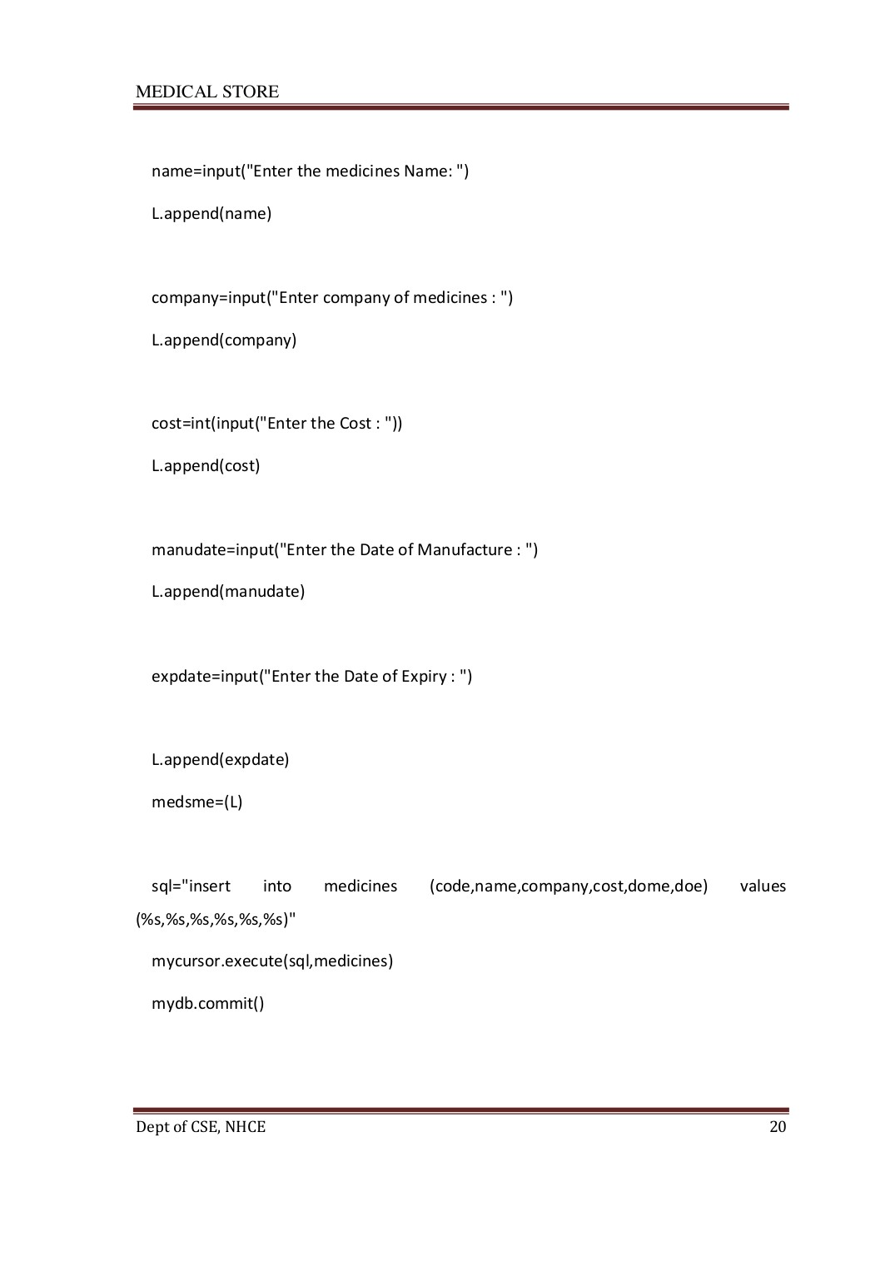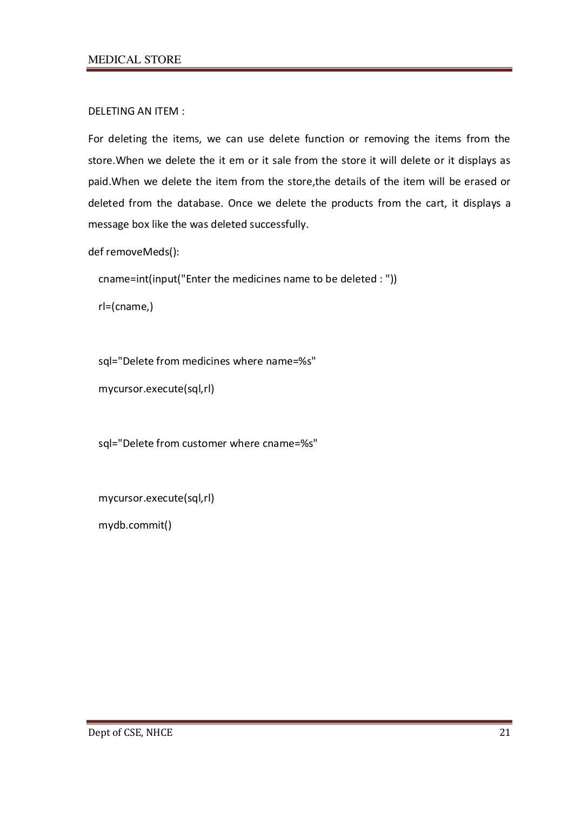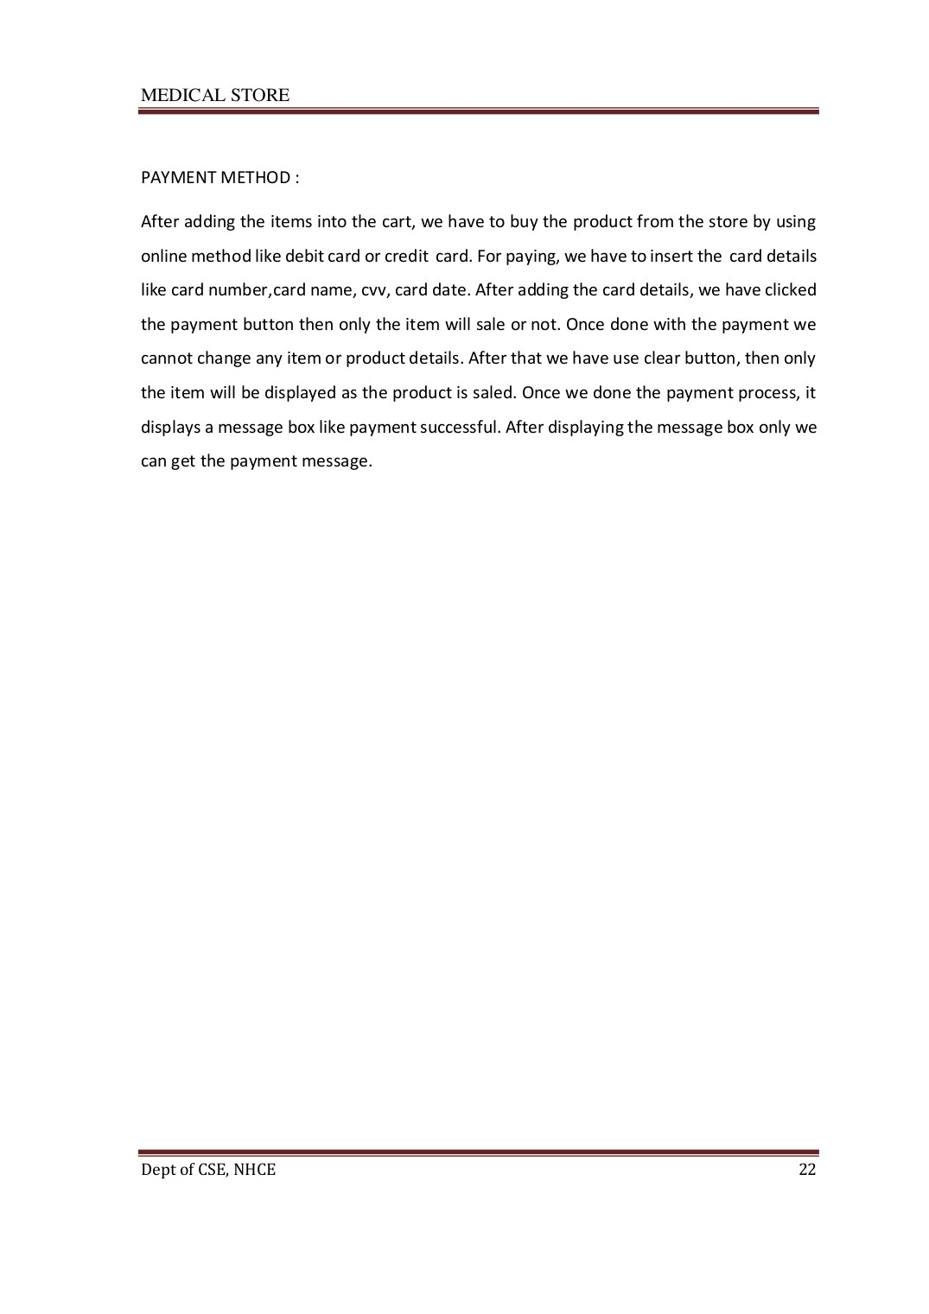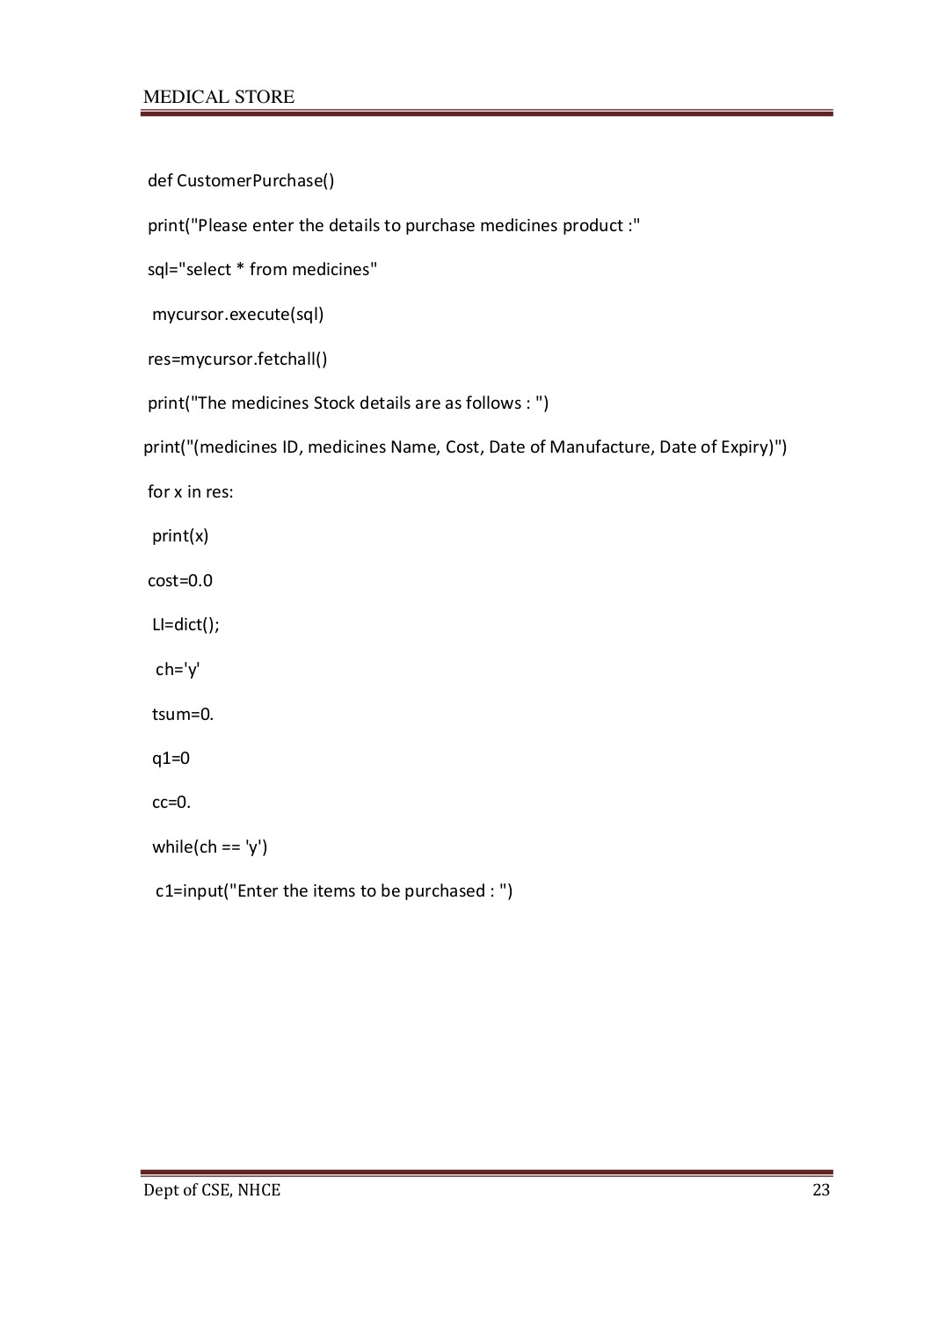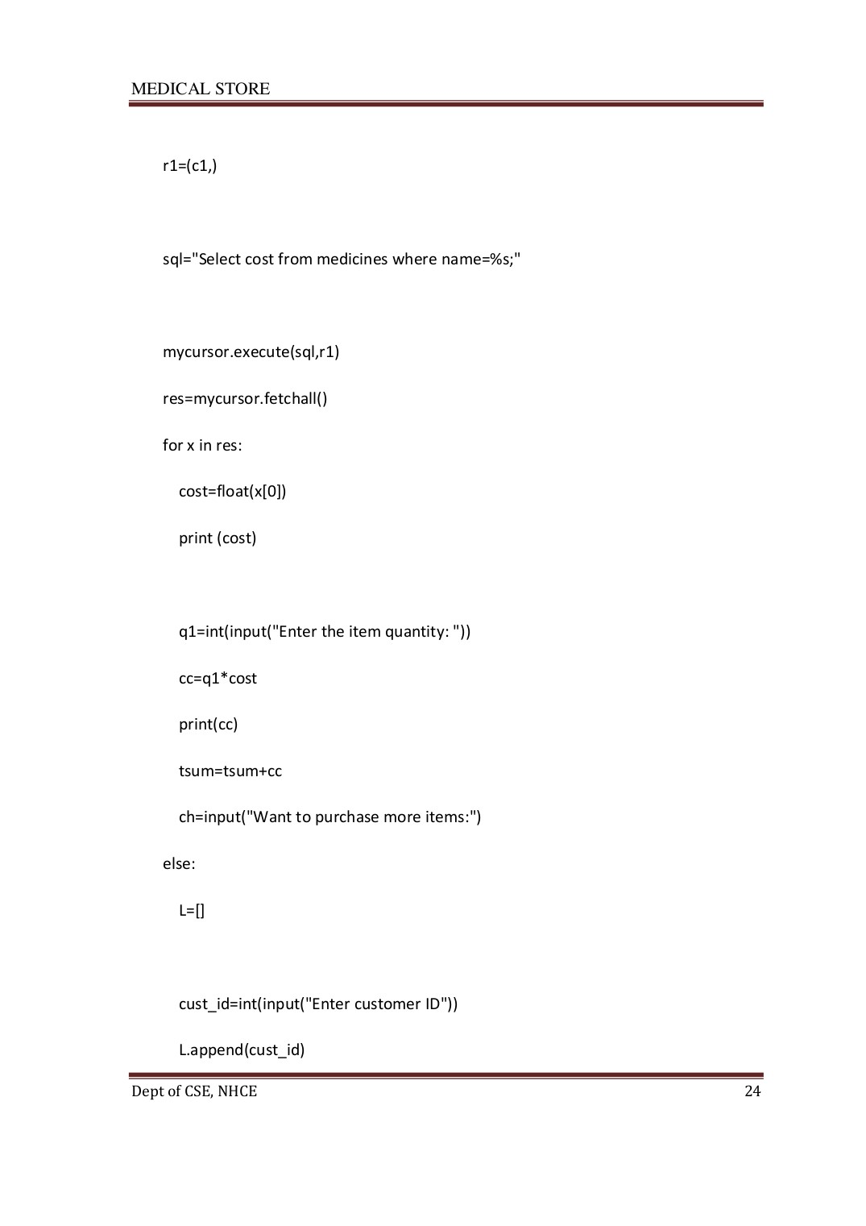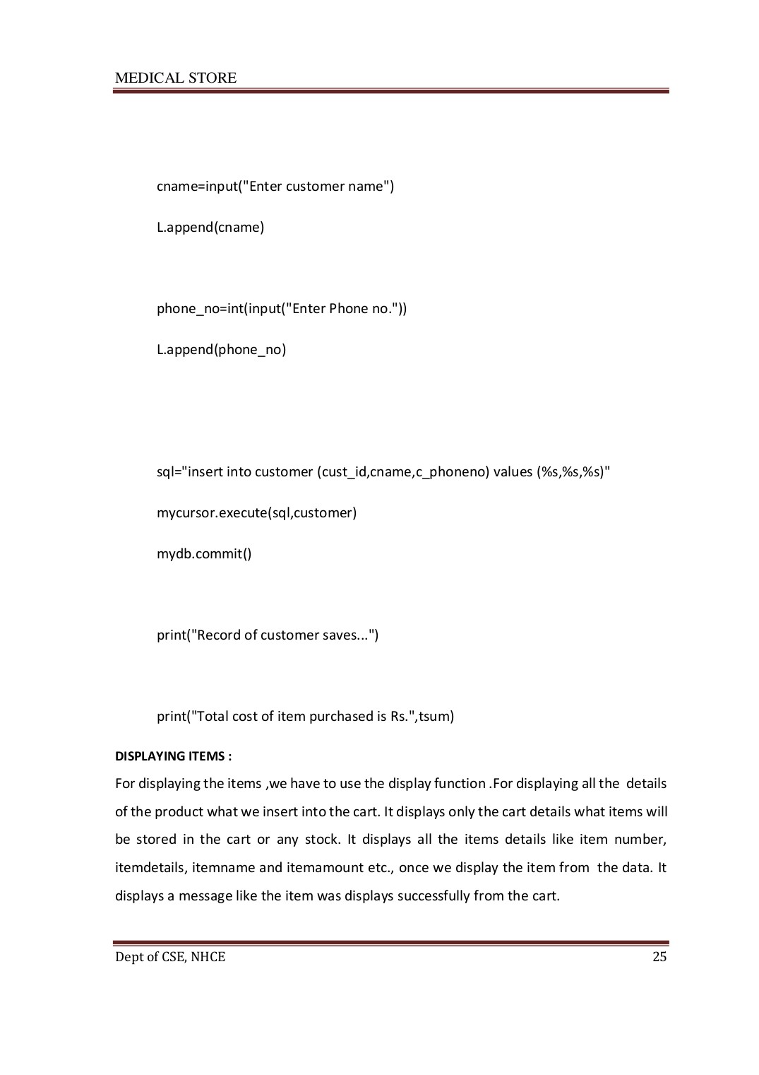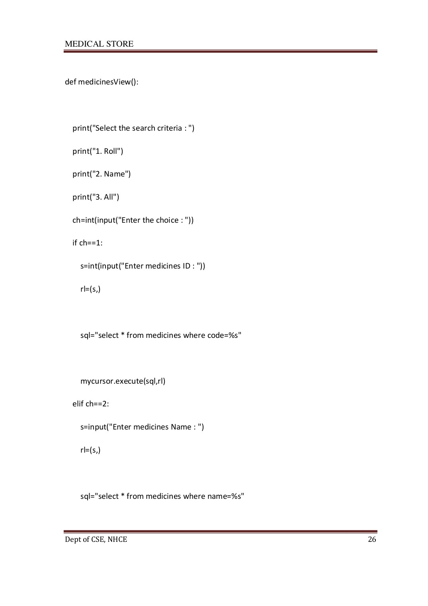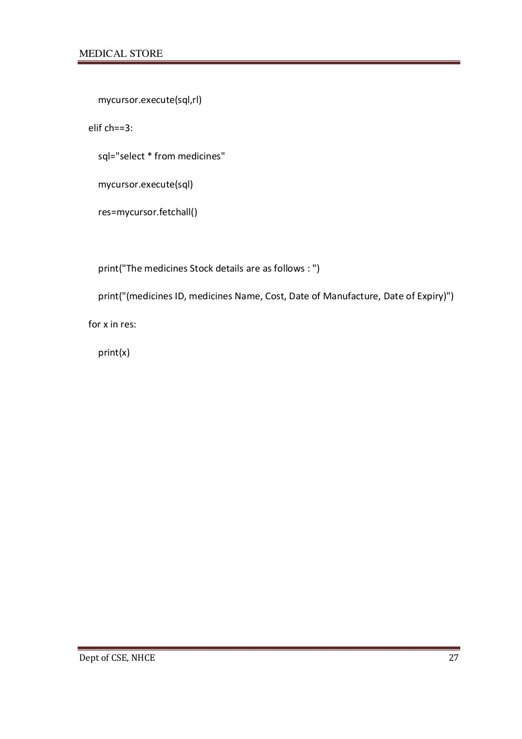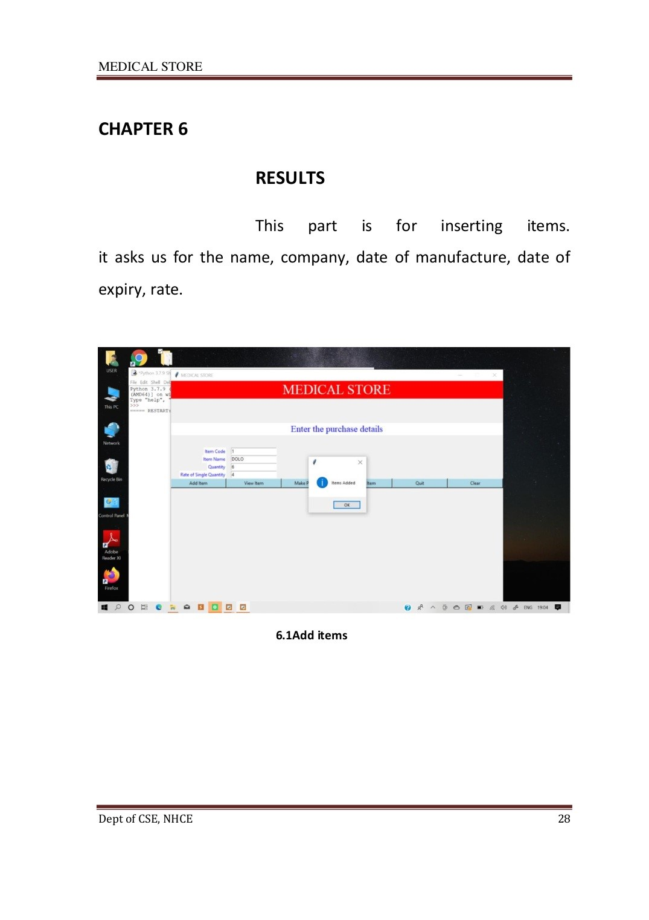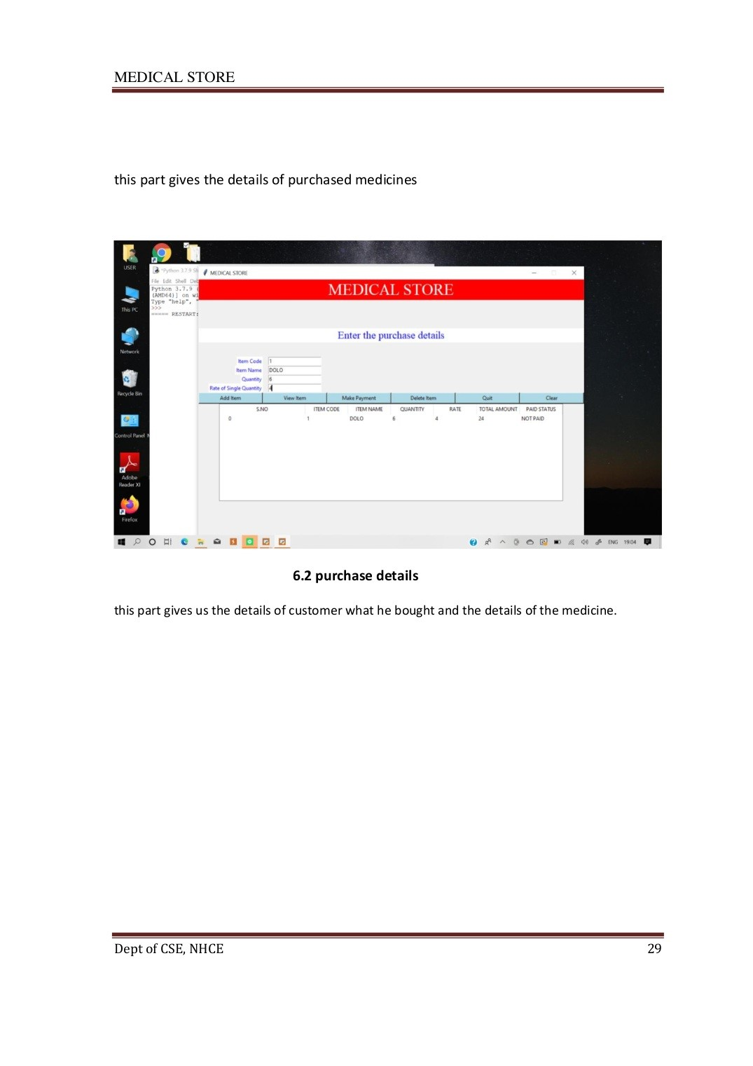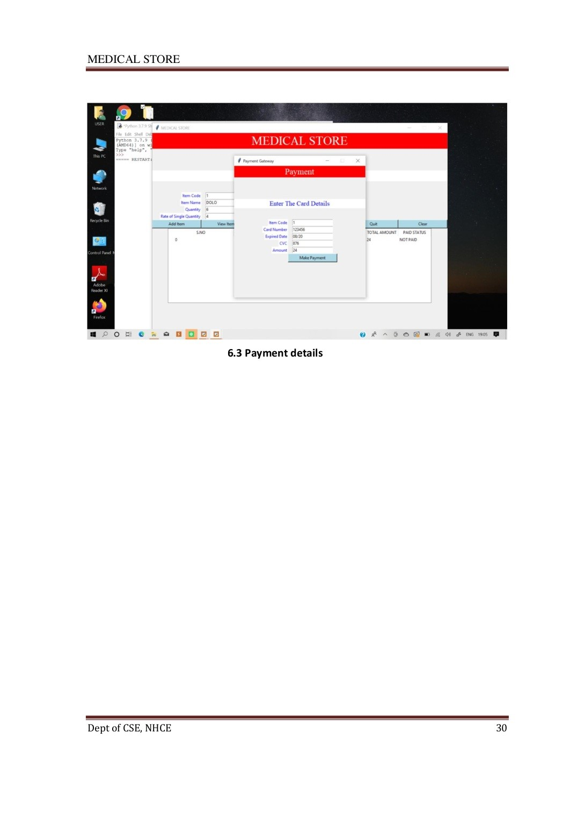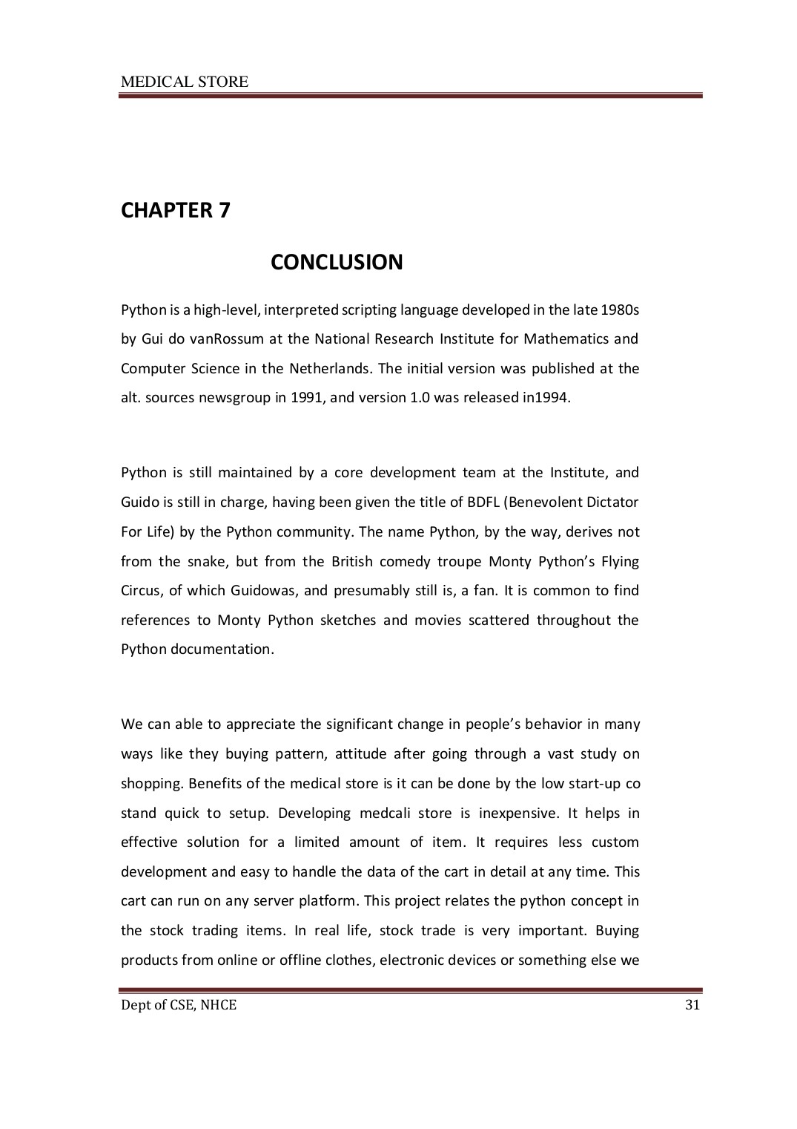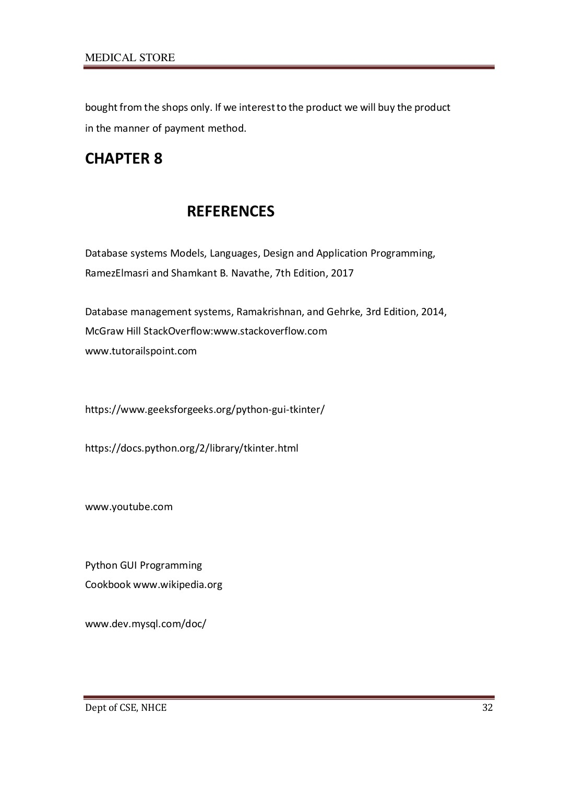

MEDICAL STORE

# ORIGINALITY REPORT

3% % 3% %

SIMILARITY INDEX INTERNET SOURCES PUBLICATIONS STUDENT PAPERS

|  |  |
| --- | --- |
| PRIMARY SOURCES |  |
| Ossama Embarak. "Chapter 1 Introduction to 1  Data Science with Python", Springer Science and Business Media LLC, 2018  Publication | 1% |
| Connor P. Milliken. "Chapter 5 Functions",  2  Springer Science and Business Media LLC,  2020  Publication | 1% |
| Huang, Bao Hua, Tian Jing Wang, Yan Ma, and 3  Feng Jiang. "Encrypting Database Content with User-Defined Function", Applied Mechanics and Materials, 2014.  Publication | 1% |
| Sahar Vahdati, Said Fathalla, Christoph Lange, 4  Andreas Behrend, Aysegul Say, Zeynep Say, Sören Auer. "A comprehensive quality assessment framework for scientific events",  Scientometrics, 2020  Publication | 1% |

Salma A. Essam El-Din, Mohamed A. Abd El-

5 <1%

Ghany. "Sign Language Interpreter System: An alternative system for machine learning", 2020

2nd Novel Intelligent and Leading Emerging

# Sciences Conference (NILES), 2020

Publication

|  |  |
| --- | --- |
| William J. Rasdorf, Osama Y. Abudayyeh.  6  "NIAM Conceptual Data**‐**Base Design in  Construction Management", Journal of  Computing in Civil Engineering, 1992  Publication | <1% |
| Manohar Swamynathan. "Chapter 1 Step 1 – 7  Getting Started in Python", Springer Science and Business Media LLC, 2017  Publication | <1% |

Exclude quotes Off Exclude matches Off

Exclude bibliography On